**Gantt Chart:**

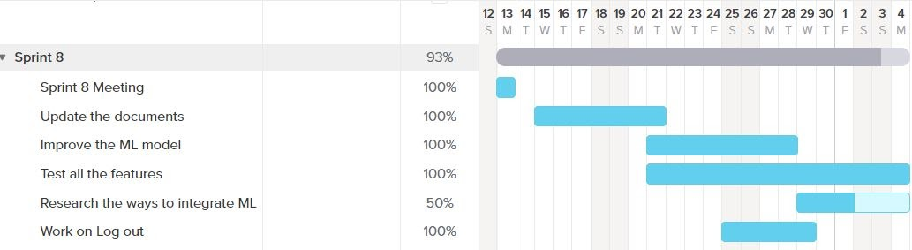

**Sprint Goal:**

Work on improving the CNN model. Work in updating all the documents. Test all the features and fox bugs. Research on ways to integrate the machine learning model into our web application.

**Sprint Retrospective:**

We did not meet out sprint goal. We completed most of the tasks. 51 story points were planned for this sprint and only 41 points were completed. We spent a total of 90 hours collectively as a team this sprint working on our application. In this sprint, we were able to complete all the tasks by the given deadlines and this was possible with good communication within the group. We did not have enough time to fox bugs. We should have spread the tasks evenly throughout the sprint. We decided which stories have highest priorities based in what features needed updates and needed fixing of bugs. We have one in-progress user story this sprint. The burndown chart did not exactly look linear because in the beginning of the sprint, we focused on updating the documents and then we worked on the coding section. The two sprint retrospective conclusions are: researching and working with machine learning model consumed a lot of time, deciding on different ways to integrate our ML model was hard and we did not have enough time to integrate the ML model into our web application.